UNIVERSITY INSTITUTE OF COMPUTING

PROJECT ON
Process Control and Job Scheduling in Linux Program Name: BCA
Subject Name/Code: COMPUTING APTITUDE/23CAP-308




Submitted by: RETS’EPILE TS’EHLANA
Submitted to:
UID: 23BCA10496 Mr. RAJAT PATIAL
Section: 23BCA – 3 ‘A’

INTRODUCTION:
In Linux, process control is a core part of system administration. Every program or command runs as a process, and the administrator can control these processes—start, stop, prioritize, or schedule them.
Linux provides commands like ps, kill, nice, top, bg, fg, and jobs to manage running processes.
For automated execution, Linux uses cron jobs via the crontab command, which allows users to schedule scripts or commands at specific times.

OBJECTIVE
OBJECTIVES:
To understand and demonstrate how Linux manages processes and how to control or schedule them using process management and job scheduling commands.
COMMANDS:
Command | Description | Example
ps | Displays current running processes | ps -ef
top | Shows real-time process activity | top
kill | Terminates a process by PID | kill -9 1023
nice | Starts a process with a given priority | nice -n 10 firefox
renice | Changes priority of an existing process | renice 5 -p 1023
jobs | Lists background/stopped jobs | jobs
bg | Resumes a stopped job in background | bg %1
fg | Brings a job to foreground | fg %1
cron | Background daemon for scheduling | sudo service cron start
crontab | Manages cron jobs for scheduling | crontab -e

ALGORITHM:
A. Process Management
- Open the terminal.
- Type ps -ef to list all running processes.
- Identify a process PID using ps or top.
- Use kill PID to terminate the selected process.
- Start a process with lower priority using nice -n 10 program_name.
- Change its priority later using renice.
- Run a process in background using & (example: gedit &).
- Use jobs to view job list and fg or bg to control them.

SOURCE CODE:
B. Job Scheduling with crontab
- Open crontab editor:
- crontab -e
- Add a line to schedule a script or command.
Example: Run backup.sh every day at 7 AM.
- 0 7 * * * /home/user/backup.sh
- Save and exit the editor.
- View current scheduled jobs:
- crontab -l
- Remove scheduled jobs:
- crontab -r

7. Example Demonstration
Example 1: View running processes
ps -ef
Output shows all running processes with PID, user, and command.
Example 2: Kill a process
kill -9 1234
Terminates the process with PID 1234.
Example 3: Run a program with lower priority
nice -n 10 gedit &
Example 4: Schedule automatic task
Add to crontab:
*/5 * * * * echo "Hello, Linux" >> /home/user/output.txt
This command appends “Hello, Linux” to the file every 5 minutes.

8. Output Screenshots (for your practical file)
Include screenshots of:
- ps -ef output
- kill command usage
- nice or renice command in action
- Crontab job list using crontab -l
- Output file generated by cron job

SAMPLE OUTPUT
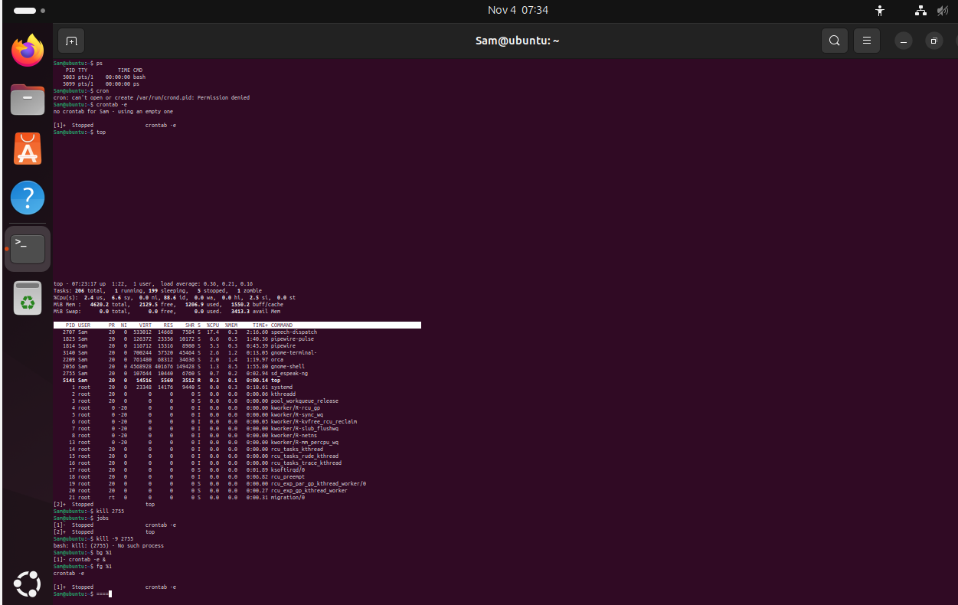

CONCLUSION:
This project demonstrates how Linux provides powerful tools for managing processes and scheduling tasks.
Using process commands, users can control CPU usage, terminate unresponsive applications, and set process priorities.
Using cron jobs, repetitive administrative tasks can be automated, improving efficiency and reliability.

FUTURE SCOPE:
• Integrate process monitoring scripts with system logging.
• Use at command for one-time scheduling.
• Implement advanced scheduling using systemd timers.
• Create graphical interfaces for easier job control.

